**Confidence scores for each possible classification. Red entries are where the correct classification was not the most confident answer.**

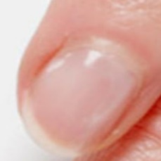  
normal#0 **Confidences:**normal = 80%; fungal = 20%;   
The nail's condition is normal with confidence score of 80%. Otherwise it is fungal with confidence score of 20%.  
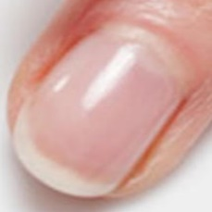  
normal#1 **Confidences:**normal = 100%; fungal = 0%;   
The nail's condition is normal with confidence score of 100%.  
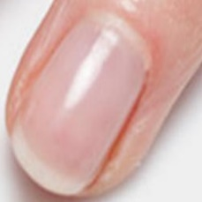  
normal#2 **Confidences:**normal = 100%; fungal = 0%;   
The nail's condition is normal with confidence score of 100%.  
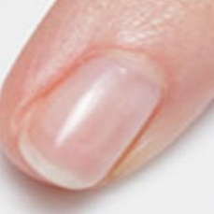  
normal#3 **Confidences:**normal = 100%; fungal = 0%;   
The nail's condition is normal with confidence score of 100%.  
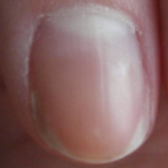  
normal#4 **Confidences:**normal = 100%; fungal = 0%;   
The nail's condition is normal with confidence score of 100%.  
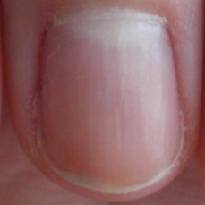  
normal#5 **Confidences:**normal = 100%; fungal = 0%;   
The nail's condition is normal with confidence score of 100%.  
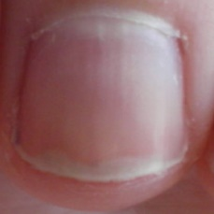  
normal#6 **Confidences:**normal = 100%; fungal = 0%;   
The nail's condition is normal with confidence score of 100%.  
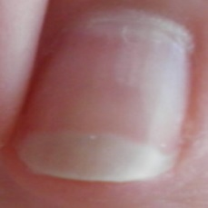  
normal#7 **Confidences:**normal = 100%; fungal = 0%;   
The nail's condition is normal with confidence score of 100%.  
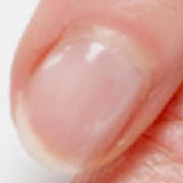  
normal#8 **Confidences:**normal = 80%; fungal = 20%;   
The nail's condition is normal with confidence score of 80%. Otherwise it is fungal with confidence score of 20%.  
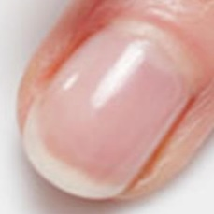  
normal#9 **Confidences:**normal = 100%; fungal = 0%;   
The nail's condition is normal with confidence score of 100%.  
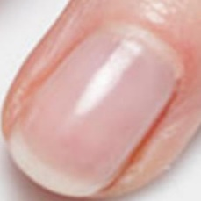  
normal#10 **Confidences:**normal = 100%; fungal = 0%;   
The nail's condition is normal with confidence score of 100%.  
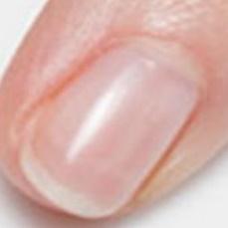  
normal#11 **Confidences:**normal = 100%; fungal = 0%;   
The nail's condition is normal with confidence score of 100%.  
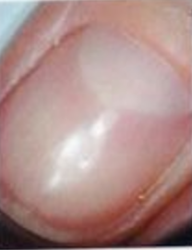  
normal#12 **Confidences:**normal = 100%; fungal = 0%;   
The nail's condition is normal with confidence score of 100%.  
http://localhost:8080/ai/onyx/images/normal/Fingernail%20healthy%20Image_14a.png  
normal#13 **Confidences:**normal = 100%; fungal = 0%;   
The nail's condition is normal with confidence score of 100%.  
http://localhost:8080/ai/onyx/images/normal/Fingernail%20healthy%20Image_14b.png  
normal#14 **Confidences:**normal = 100%; fungal = 0%;   
The nail's condition is normal with confidence score of 100%.  
http://localhost:8080/ai/onyx/images/normal/Fingernail%20healthy%20Image_14c.png  
normal#15 **Confidences:**normal = 100%; fungal = 0%;   
The nail's condition is normal with confidence score of 100%.  
http://localhost:8080/ai/onyx/images/normal/Fingernail%20healthy%20Image_14d.png  
normal#16 **Confidences:**normal = 100%; fungal = 0%;   
The nail's condition is normal with confidence score of 100%.  
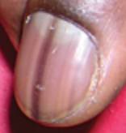  
normal#17 **Confidences:**normal = 100%; fungal = 0%;   
The nail's condition is normal with confidence score of 100%.  
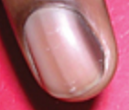  
normal#18 **Confidences:**normal = 100%; fungal = 0%;   
The nail's condition is normal with confidence score of 100%.  
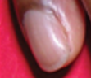  
normal#19 **Confidences:**normal = 100%; fungal = 0%;   
The nail's condition is normal with confidence score of 100%.  
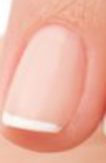  
normal#20 **Confidences:**normal = 100%; fungal = 0%;   
The nail's condition is normal with confidence score of 100%.  
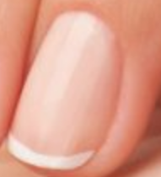  
normal#21 **Confidences:**normal = 100%; fungal = 0%;   
The nail's condition is normal with confidence score of 100%.  
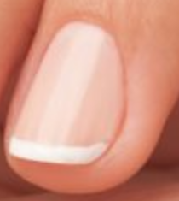  
normal#22 **Confidences:**normal = 100%; fungal = 0%;   
The nail's condition is normal with confidence score of 100%.  
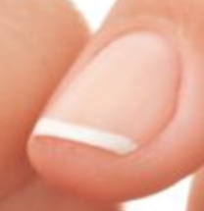  
normal#23 **Confidences:**normal = 100%; fungal = 0%;   
The nail's condition is normal with confidence score of 100%.  
http://localhost:8080/ai/onyx/images/normal/Fingernail%20healthy%20Image_18a.png  
normal#24 **Confidences:**normal = 100%; fungal = 0%;   
The nail's condition is normal with confidence score of 100%.  
http://localhost:8080/ai/onyx/images/normal/Fingernail%20healthy%20Image_18b.png  
normal#25 **Confidences:**normal = 100%; fungal = 0%;   
The nail's condition is normal with confidence score of 100%.  
http://localhost:8080/ai/onyx/images/normal/Fingernail%20healthy%20Image_18c.png  
normal#26 **Confidences:**normal = 100%; fungal = 0%;   
The nail's condition is normal with confidence score of 100%.  
http://localhost:8080/ai/onyx/images/normal/Fingernail%20healthy%20Image_18d.png  
normal#27 **Confidences:**normal = 100%; fungal = 0%;   
The nail's condition is normal with confidence score of 100%.  
http://localhost:8080/ai/onyx/images/normal/Fingernail%20healthy%20Image_18e.png  
normal#28 **Confidences:**normal = 100%; fungal = 0%;   
The nail's condition is normal with confidence score of 100%.  
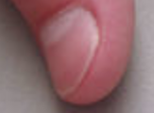  
normal#29 **Confidences:**normal = 100%; fungal = 0%;   
The nail's condition is normal with confidence score of 100%.  
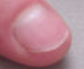  
normal#30 **Confidences:**normal = 100%; fungal = 0%;   
The nail's condition is normal with confidence score of 100%.  
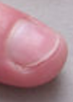  
normal#31 **Confidences:**normal = 100%; fungal = 0%;   
The nail's condition is normal with confidence score of 100%.  
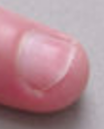  
normal#32 **Confidences:**normal = 100%; fungal = 0%;   
The nail's condition is normal with confidence score of 100%.  
  
normal#33 **Confidences:**normal = 100%; fungal = 0%;   
The nail's condition is normal with confidence score of 100%.  
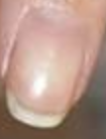  
normal#34 **Confidences:**normal = 100%; fungal = 0%;   
The nail's condition is normal with confidence score of 100%.  
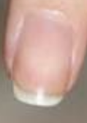  
normal#35 **Confidences:**normal = 100%; fungal = 0%;   
The nail's condition is normal with confidence score of 100%.  
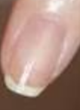  
normal#36 **Confidences:**normal = 100%; fungal = 0%;   
The nail's condition is normal with confidence score of 100%.  
  
normal#37 **Confidences:**normal = 100%; fungal = 0%;   
The nail's condition is normal with confidence score of 100%.  
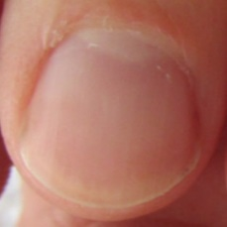  
normal#38 **Confidences:**normal = 100%; fungal = 0%;   
The nail's condition is normal with confidence score of 100%.  
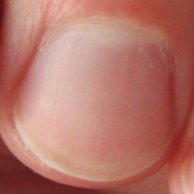  
normal#39 **Confidences:**normal = 100%; fungal = 0%;   
The nail's condition is normal with confidence score of 100%.  
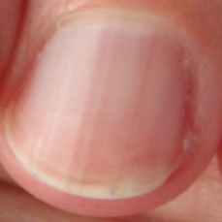  
normal#40 **Confidences:**normal = 100%; fungal = 0%;   
The nail's condition is normal with confidence score of 100%.  
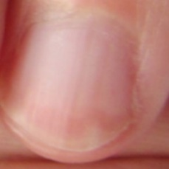  
normal#41 **Confidences:**normal = 100%; fungal = 0%;   
The nail's condition is normal with confidence score of 100%.  
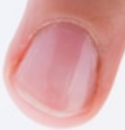  
normal#42 **Confidences:**normal = 100%; fungal = 0%;   
The nail's condition is normal with confidence score of 100%.  
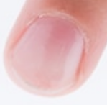  
normal#43 **Confidences:**normal = 80%; fungal = 20%;   
The nail's condition is normal with confidence score of 80%. Otherwise it is fungal with confidence score of 20%.  
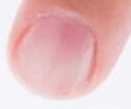  
normal#44 **Confidences:**normal = 100%; fungal = 0%;   
The nail's condition is normal with confidence score of 100%.  
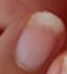  
normal#45 **Confidences:**normal = 100%; fungal = 0%;   
The nail's condition is normal with confidence score of 100%.  
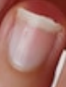  
normal#46 **Confidences:**normal = 100%; fungal = 0%;   
The nail's condition is normal with confidence score of 100%.  
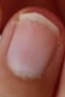  
normal#47 **Confidences:**normal = 100%; fungal = 0%;   
The nail's condition is normal with confidence score of 100%.  
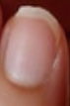  
normal#48 **Confidences:**normal = 100%; fungal = 0%;   
The nail's condition is normal with confidence score of 100%.  
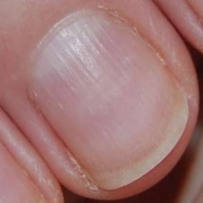  
normal#49 **Confidences:**normal = 100%; fungal = 0%;   
The nail's condition is normal with confidence score of 100%.  
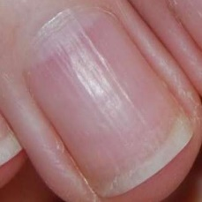  
normal#50 **Confidences:**normal = 100%; fungal = 0%;   
The nail's condition is normal with confidence score of 100%.  
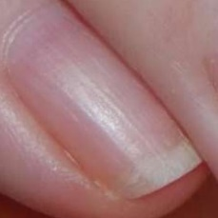  
normal#51 **Confidences:**normal = 100%; fungal = 0%;   
The nail's condition is normal with confidence score of 100%.  
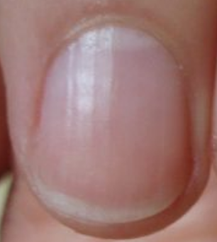  
normal#52 **Confidences:**normal = 100%; fungal = 0%;   
The nail's condition is normal with confidence score of 100%.  
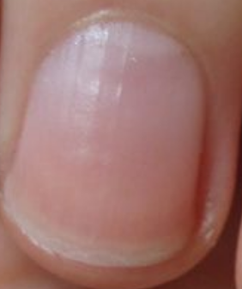  
normal#53 **Confidences:**normal = 100%; fungal = 0%;   
The nail's condition is normal with confidence score of 100%.  
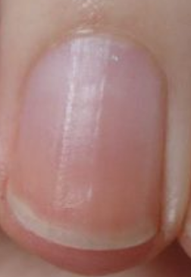  
normal#54 **Confidences:**normal = 100%; fungal = 0%;   
The nail's condition is normal with confidence score of 100%.  
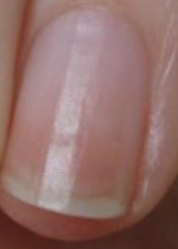  
normal#55 **Confidences:**normal = 100%; fungal = 0%;   
The nail's condition is normal with confidence score of 100%.  
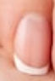  
normal#56 **Confidences:**normal = 100%; fungal = 0%;   
The nail's condition is normal with confidence score of 100%.  
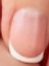  
normal#57 **Confidences:**normal = 100%; fungal = 0%;   
The nail's condition is normal with confidence score of 100%.  
http://localhost:8080/ai/onyx/images/normal/Fingernail%20healthy%20Image_7c.png  
normal#58 **Confidences:**normal = 100%; fungal = 0%;   
The nail's condition is normal with confidence score of 100%.  
http://localhost:8080/ai/onyx/images/normal/Fingernail%20healthy%20Image_7d.png  
normal#59 **Confidences:**normal = 100%; fungal = 0%;   
The nail's condition is normal with confidence score of 100%.  
http://localhost:8080/ai/onyx/images/normal/Fingernail%20healthy%20Image_8a.png  
normal#60 **Confidences:**normal = 100%; fungal = 0%;   
The nail's condition is normal with confidence score of 100%.  
http://localhost:8080/ai/onyx/images/normal/Fingernail%20healthy%20Image_8b.png  
normal#61 **Confidences:**normal = 100%; fungal = 0%;   
The nail's condition is normal with confidence score of 100%.  
http://localhost:8080/ai/onyx/images/normal/Fingernail%20healthy%20Image_8c.png  
normal#62 **Confidences:**normal = 100%; fungal = 0%;   
The nail's condition is normal with confidence score of 100%.  
http://localhost:8080/ai/onyx/images/normal/Fingernail%20healthy%20Image_8d.png  
normal#63 **Confidences:**normal = 100%; fungal = 0%;   
The nail's condition is normal with confidence score of 100%.  
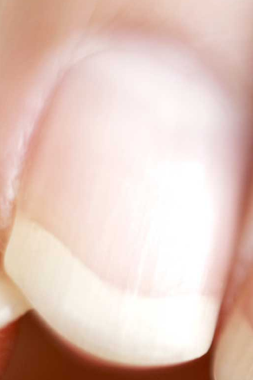  
normal#64 **Confidences:**normal = 100%; fungal = 0%;   
The nail's condition is normal with confidence score of 100%.  
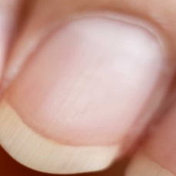  
normal#65 **Confidences:**normal = 100%; fungal = 0%;   
The nail's condition is normal with confidence score of 100%.  
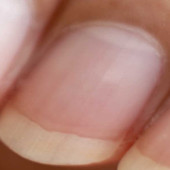  
normal#66 **Confidences:**normal = 100%; fungal = 0%;   
The nail's condition is normal with confidence score of 100%.  
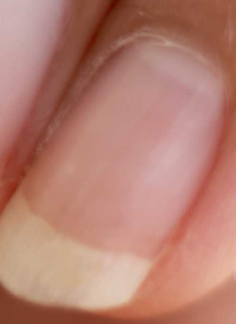  
normal#67 **Confidences:**normal = 100%; fungal = 0%;   
The nail's condition is normal with confidence score of 100%.  
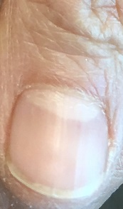  
normal#68 **Confidences:**normal = 100%; fungal = 0%;   
The nail's condition is normal with confidence score of 100%.

Number whose highest confidence score is the correct answer = 69/69 (100%)

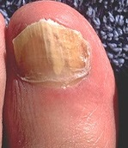  
fungal#0 **Confidences:**normal = 20%; fungal = 80%;   
The nail's condition is fungal with confidence score of 80%. Otherwise it is normal with confidence score of 20%.  
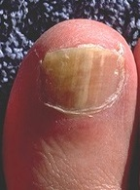  
fungal#1 **Confidences:**normal = 60%; fungal = 40%;   
The nail's condition is normal with confidence score of 60%. Otherwise it is fungal with confidence score of 40%.  
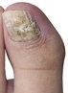  
fungal#2 **Confidences:**normal = 20%; fungal = 80%;   
The nail's condition is fungal with confidence score of 80%. Otherwise it is normal with confidence score of 20%.  
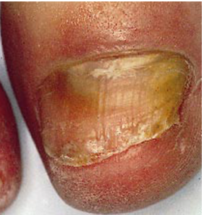  
fungal#3 **Confidences:**normal = 0%; fungal = 100%;   
The nail's condition is fungal with confidence score of 100%.  
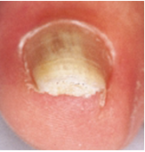  
fungal#4 **Confidences:**normal = 0%; fungal = 100%;   
The nail's condition is fungal with confidence score of 100%.  
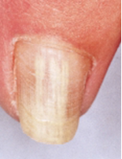  
fungal#5 **Confidences:**normal = 0%; fungal = 100%;   
The nail's condition is fungal with confidence score of 100%.  
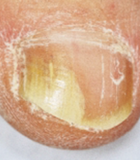  
fungal#6 **Confidences:**normal = 0%; fungal = 100%;   
The nail's condition is fungal with confidence score of 100%.  
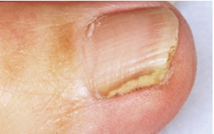  
fungal#7 **Confidences:**normal = 0%; fungal = 100%;   
The nail's condition is fungal with confidence score of 100%.  
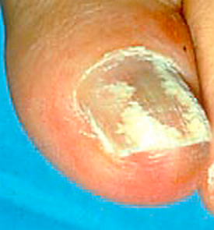  
fungal#8 **Confidences:**normal = 0%; fungal = 100%;   
The nail's condition is fungal with confidence score of 100%.  
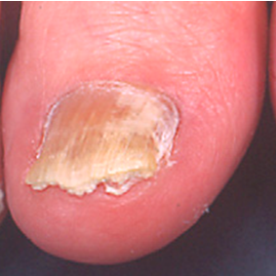  
fungal#9 **Confidences:**normal = 0%; fungal = 100%;   
The nail's condition is fungal with confidence score of 100%.  
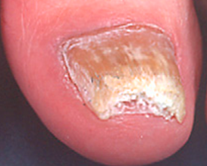  
fungal#10 **Confidences:**normal = 0%; fungal = 100%;   
The nail's condition is fungal with confidence score of 100%.  
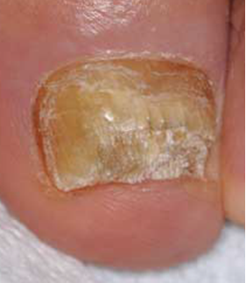  
fungal#11 **Confidences:**normal = 0%; fungal = 100%;   
The nail's condition is fungal with confidence score of 100%.  
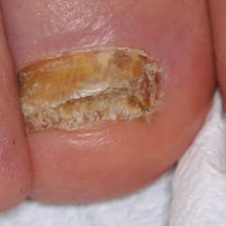  
fungal#12 **Confidences:**normal = 0%; fungal = 100%;   
The nail's condition is fungal with confidence score of 100%.  
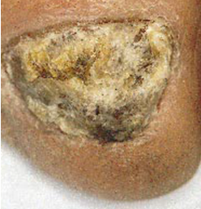  
fungal#13 **Confidences:**normal = 0%; fungal = 100%;   
The nail's condition is fungal with confidence score of 100%.  
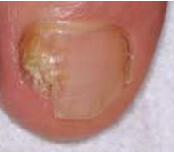  
fungal#14 **Confidences:**normal = 0%; fungal = 100%;   
The nail's condition is fungal with confidence score of 100%.  
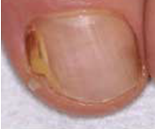  
fungal#15 **Confidences:**normal = 0%; fungal = 100%;   
The nail's condition is fungal with confidence score of 100%.  
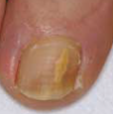  
fungal#16 **Confidences:**normal = 0%; fungal = 100%;   
The nail's condition is fungal with confidence score of 100%.  
http://localhost:8080/ai/onyx/images/fungal-nails/Slide22-1b.png  
fungal#17 **Confidences:**normal = 0%; fungal = 100%;   
The nail's condition is fungal with confidence score of 100%.  
http://localhost:8080/ai/onyx/images/fungal-nails/Slide22-1c.png  
fungal#18 **Confidences:**normal = 0%; fungal = 100%;   
The nail's condition is fungal with confidence score of 100%.  
http://localhost:8080/ai/onyx/images/fungal-nails/Slide22-1d.png  
fungal#19 **Confidences:**normal = 0%; fungal = 100%;   
The nail's condition is fungal with confidence score of 100%.  
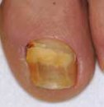  
fungal#20 **Confidences:**normal = 20%; fungal = 80%;   
The nail's condition is fungal with confidence score of 80%. Otherwise it is normal with confidence score of 20%.  
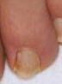  
fungal#21 **Confidences:**normal = 0%; fungal = 100%;   
The nail's condition is fungal with confidence score of 100%.  
http://localhost:8080/ai/onyx/images/fungal-nails/Slide22-2c.png  
fungal#22 **Confidences:**normal = 0%; fungal = 100%;   
The nail's condition is fungal with confidence score of 100%.  
http://localhost:8080/ai/onyx/images/fungal-nails/Slide22-2d.png  
fungal#23 **Confidences:**normal = 0%; fungal = 100%;   
The nail's condition is fungal with confidence score of 100%.  
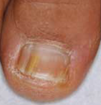  
fungal#24 **Confidences:**normal = 0%; fungal = 100%;   
The nail's condition is fungal with confidence score of 100%.  
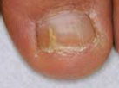  
fungal#25 **Confidences:**normal = 0%; fungal = 100%;   
The nail's condition is fungal with confidence score of 100%.  
http://localhost:8080/ai/onyx/images/fungal-nails/Slide22-3c.png  
fungal#26 **Confidences:**normal = 0%; fungal = 100%;   
The nail's condition is fungal with confidence score of 100%.  
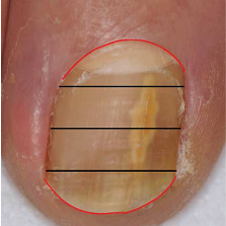  
fungal#27 **Confidences:**normal = 0%; fungal = 100%;   
The nail's condition is fungal with confidence score of 100%.  
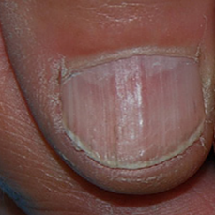  
fungal#28 **Confidences:**normal = 80%; fungal = 20%;   
The nail's condition is normal with confidence score of 80%. Otherwise it is fungal with confidence score of 20%.  
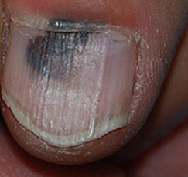  
fungal#29 **Confidences:**normal = 40%; fungal = 60%;   
The nail's condition is fungal with confidence score of 60%. Otherwise it is normal with confidence score of 40%.  
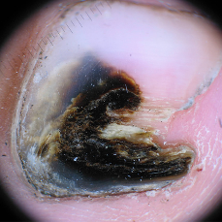  
fungal#30 **Confidences:**normal = 20%; fungal = 80%;   
The nail's condition is fungal with confidence score of 80%. Otherwise it is normal with confidence score of 20%.  
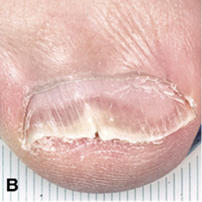  
fungal#31 **Confidences:**normal = 0%; fungal = 100%;   
The nail's condition is fungal with confidence score of 100%.  
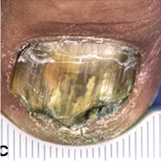  
fungal#32 **Confidences:**normal = 0%; fungal = 100%;   
The nail's condition is fungal with confidence score of 100%.  
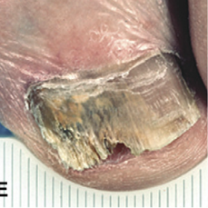  
fungal#33 **Confidences:**normal = 0%; fungal = 100%;   
The nail's condition is fungal with confidence score of 100%.  
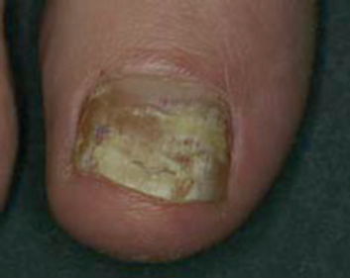  
fungal#34 **Confidences:**normal = 20%; fungal = 80%;   
The nail's condition is fungal with confidence score of 80%. Otherwise it is normal with confidence score of 20%.  
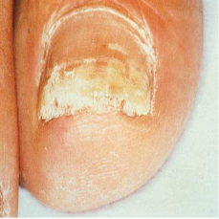  
fungal#35 **Confidences:**normal = 0%; fungal = 100%;   
The nail's condition is fungal with confidence score of 100%.  
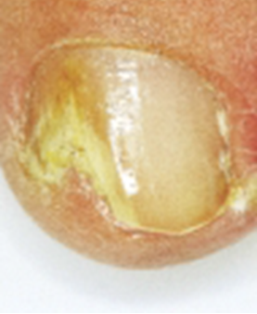  
fungal#36 **Confidences:**normal = 0%; fungal = 100%;   
The nail's condition is fungal with confidence score of 100%.  
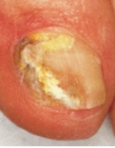  
fungal#37 **Confidences:**normal = 0%; fungal = 100%;   
The nail's condition is fungal with confidence score of 100%.

Number whose highest confidence score is the correct answer = 36/38 (95%)

true positives = 36  
true negatives = 69  
false positives = 0  
false negatives = 2  
not confident of any answer = 0  
total = 107  
  
sensitivity = 0.9474  
specificity = 1  
precision = 1  
recall = 0.9474